St. Kieran K of C KNIGHTLETTER

**Council # 13983 SEPTEMBER/OCTOBER, 2020**



**From The Grand Knight**

***Dear Brothers, Officers, Families, Parishioners, and all others who find their way to this article***:

I want to bring you all up to speed on what has been happening with the St. Kieran Knights of Columbus Council 13983. First, on July 1, 2020, I became the Grand Knight. I was selected by the men of the Council to this leadership post, and I am incredibly humbled by this. These are some of the finest people I have ever met, and it is truly an honor for me to be part of such a great organization. Second, as you all know, 2020 has been an extremely challenging year to say the least. The Knights are not immune to the hardships that Covid 19 has spread throughout the world. As such, our ability to conduct our traditional fundraising events have been cancelled or postponed. Therefore, our ability to assist charities has been drastically reduced. As of this writing, we continue to plan for our Fall MI-Drive (Tootsie Roll sales) and our rescheduled JINGO event, along with several other annual events that the Knights participate. Our member ship continues to grow, even during these trying times. There has never been more need or a better time for the good Catholic Men of our community to join our team and belong to something bigger! As the saying goes, **YOU were born a MAN, YOU became a Knight!**

Scheduled upcoming events that you and your family can participate in include the Parish Picnic, September 13, 2020, following the 11:30 Mass. We will need many volunteers to assist with this event and to make it better than ever. See any Knight or Usher for details. Our annual Fall MI-Drive, Scheduled for the weekend of October 9 – 11, 2020. There are still a few tickets remaining for the JINGO event, which is scheduled for November 19, 2020. Ushers and Knights can provide information on this as well. We continue to pray the Rosary every Sunday at 1:00 pm via Zoom. You can email Ron at [drkosc47@hotmail.com](mailto:drkosc47@hotmail.com) to get more information or to volunteer to lead a decade.

I want to take this time to thank my fellow Knights for the confidence that they have shown in me. I especially want to thank the Officers of Council 13983 for their hard work and dedication. Special thanks to Past Grand Knight Engler for his guidance through this transition. I may be contacted at [GK13983@gmail.com](mailto:GK13983@gmail.com).

VIVAT JESUS!

*John A. Berg*

*Grand Knight*

**OFFICERS for FRATERNAL YEAR 2019/2020**:

Grand Knight; John Berg Inside Guard: Chris Fox Outside Guard; Don Watchowski

Deputy Grand Knight; Carl Barton Inside Guard; Al Jankowski Outside Guard: Chris Nnaji

Chancellor; Kenneth Kwasnik Inside Guard: John Benincasa Outside Guard; Chris Doran

Financial Secretary; Roger Quitter Inside Guard; Mark Semaan

Warden; Mike Powers Chaplain; Advocate; Ron Koscierzynski

Recorder; Joseph Vogel Trustee 1st; Russ Morgan Trustee 2nd; Bob Ansell

Treasurer: Tom Westerlund Trustee 3rd: Ralph Engler Lecturer; Tom Petz

**UPCOMING EVENTS;**

* 09/03/20 Officer meeting at 7:00pm (Green Room)
* 09/08/20 Membership meeting at 7:00pm (ROSARY at 6:15pm) in Day Chapel.
* 09/13/20 PARISH PICNIC starting after 11:30 Mass. **MUCH HELP IS NEEDED TO SUPPORT KIDS GAMES!!!**
* 09/20/20 St. Lawrence ROSARY & WALK for LIFE with St. Kieran participation.
* 10/08/20 Officer meeting at 7:00pm (Green Room)
* 10/09/20 thru 10/11/20 MI “Tootsie Roll” Drive
* 10/12/20 COLUMBUS DAY MEMORIAL MASS at 7:00pm with Perpetual Help Devotions immediately after Mass.
* 10/13/20 Membership meeting at 7:00pm (ROSARY at 6:15pm) in Day Chapel
* 11/07/20 Officer meeting at 7:00pm (Green Room)
* 11/12/20 Membership meeting at 7:00pm (ROSARY at 6:15pm) in Day Chapel.
* 11/19/20 JINGO still on schedule!!
* 12/10/20 CHRISTMAS CELEBRATION
* **KNIGHT of THE MONTH**;

**JULY**: Dennis Jacks who is President of the Ushers, collection counter and Acolyte and active in many other

Parish Ministries. This award came as a welcomed surprise to Dennis as he was able to attend our

first Covid19 restricted meeting since March. Our Council, Ushers and Parish are made better

by men like Dennis who lead by example. Congratulations and thanks again Dennis.

* **FAMILY of the MONTH;** Ralph & Pam Engler who have been very active in Council and Parish activities since they were

married, way back when, in what is now the Education Center. Ralph has held many positions in

the Council and fills multiple volunteer positions in the Parish while Pam leads the Son Shine Sisters

who, along with a group of assistants, send celebration cards to those receiving Sacraments and to

the homebound and ill members of the Parish.

* **ANNIVERSARIES:**

**SEPTEMBER; OCTOBER: NOVEMBER:**

12 Fred & Cathy Schroeder 01 Dennis & Sandy Jacks 05 Darrell & Sally Pawlowski

26 John & Mary Ann Devereux 04 Chris & Cheryl Doran 26 Ed & Roz Kettner

09 Al & Rosie Jankowsk 16 Ken & Jean Kwasnik

22 Wally & Bev Jakubowski

25 Larry & Lottie Grincewicz

28 Virgil & Nenita Rodriguez

**I ONLY HAVE ANNIVERSARY DATES FOR 29 MEMBERS. LET ME KNOW IF YOU WANT YOURS INCLUDED.**

* **BIRTHDAYS:**

**SEPTEMBER; OCTOBER: NOVEMBER;**

02 John Benincasa 03 Jeff Makowski 09 Jim Souva

07 Tom Westerlund 17 Steve Sawchuk 11 Paul Zairns

08 Chris Doran 22 Jim Finn 12 George Chicklas

08 Kola Gjonja 24 Joe Vogel 16 Rich Choulinard

08 Pat Wosek 21 Ed Kettner

11 FR Bob Witkowski 25 Larry Grincewicz

13 John Koscierzynski 29 Carl Barton

18 Brent Widdows 30 Al Jesperson

20 Mark Klosik

22 Pat Ryan Jr

25 Jeff Bradsher

28 Paul Skalny

* **DECEASED BROTHER KNIGHTS and their Families who need to be continually remembered our prayers:**

**SEPTEMBER; OCTOBER: NOVEMBER;**

06Manuel Vella (2011) 25 Pat Ryan (2016)

12 Bob Hallman (2018)

* **PARISH PICNIC;**

Scheduled for Sunday SEPTEMBER 13th after 11:30 Mass. We need your help in continuing to make this family event a success. We again will be staffing the Kids Games and need your help sequencing players and sanitizing between each game they play plus set up and disassembly. **All games will be conveniently played in the GYM.** More discussion will be had at our upcoming meetings.

* **JINGO**:

Due to the virus and “Stay at home directive”, the date for JINGO has been moved to **NOVEMBER 19, 2020**!

Time and location has not changed and notices have been sent out with details regarding changes. Please contact

Brother Al Jankowski, whose contact details are included in the change letter, if you have any questions. Our hope is

that you, your friends and neighbors will continue to support our efforts and those who are in need of us.

Our 2021 event is still scheduled for **Thursday April 29, 2021**, same place, time and just as much fun!

**Pray that there are no health restrictions that cause this event date to be changed. ALL those who we support are in need of the funds that we raise to keep them going. Our budget has been severely affected by having to reschedule this event from April to November and the needy are counting on us for support!!**

* **ONLINE MEETING & ROSARY**;

Special thanks to Brother Ron Koscierzynski for setting up an electronic gathering place for us to pray our

Family Rosary from March 29th through the end of July. An average of 35 to 40 members and their

families have joined weekly to pray for the end to the pandemic and those in need of our prayers. To date we

together have prayed more than 600 Rosary’s!!

We have set the goal of saying 1,000 Rosary’s for the intentions of bringing an end to the coronavirus; the health and well-being of heath care workers, first responders, ourselves, our families, and our friends; to end abortion; for an increase in vocations; for an end to bigotry; and in thanksgiving for all that we have and all that we are.

We are more than half-way there, thanks to everyone who have been praying the Rosary with us each week.  Please consider joining us each Sunday at 1:00 p.m. and help to keep our commitment to Our Lady!   The video conference is by invitation only in order to minimize the risk of being hacked.  If you would like to participate, please contact Ron Koscierzynski at 248-805-4651 or [drkosc47@hotmail.com](mailto:drkosc47@hotmail.com) to receive the log-in information.  

* **FOURTH DEGREE UPDATE;**

**From the Faithful Friar** 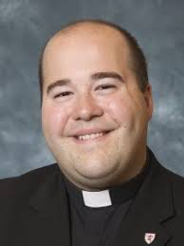

My Dear Brother Knights,

Greetings to you in our Lord Jesus! My name is Fr. James (Jim) Houbeck, Associate Pastor of St. Anastasia Catholic Church. I am grateful for the invitation to serve as Faithful Friar for the Assembly. May God give me the grace to serve you!

I have been a priest since October 2017 and I am eternally grateful to God for this life and ministry. I am also thankful to God for the great generosity and kindness of the Knights of Columbus here in Metro Detroit. Originally, my Home Council was JFK (Clinton Twp.), but I was connected to various other Councils who were generous in assisting me in my studies. Again, I am most grateful for the support the Knights provided during my studies at Sacred Heart Major Seminary!

I appreciate the service of my Brother Knights and I will do my best to assist and contribute to the good of the Order. I promise to pray for the good and well-being of the Knights, but I will also do my best to participate in the life of our Assembly, too. St. Anastasia is a busy parish, but I will try to visit you all when I am able.

May our Blessed Lord guide and bless our

Assembly, and may He give me everything I need to assist you all!

In Christ,

Fr. Jim

* **Have You Considered Joining the Fourth Degree?**

If you have ever considered joining the 4th Degree, there has never been an easier or more convenient time than now! The next Fourth Degree Exemplification will be Saturday, September 26, 2020, and will be online using Zoom. While unusual, this is being done in an abundance of caution and in keeping with current emergency orders issued by the State of Michigan Governor.

Details for logging in will be provided to Faithful Navigators and will be passed on to candidates.

The schedule will be:

9:00am Candidate Check-in

9:50am Faithful Navigator Candidate Check-in Verification

10:00am Exemplification Commences 11:45am Comments from Dignitaries

Candidate Dress Attire: Candidates need not wear a tuxedo or suit for this online event. Candidates should wear a collared shirt (dress shirt or polo shirt). Council shirts are also acceptable.

Cost: Your cost for the exemplification will only be $50 instead of the normal $70 due to the fact that there will not be a dinner served at the event.

Important Notes:

1. This is the first time we are attempting an online 4th Degree Exemplification. Please be patient with us.

2. The exemplification is expected to take about two hours.

3. Candidates are expected to be online and attentive for the entire program.

4. Exemplification to the Fourth Degree is still considered a secret ceremonial. Please distance yourself appropriately during the ceremony.

The primary purpose of the fourth degree is to foster the spirit of patriotism and to encourage active Catholic citizenship. Fourth degree Knights work to support and assist veterans and active military personnel and veterans with such programs as assisting at Veterans Administration hospitals, conducting Flag protocol programs, sending packages to troops deployed overseas, protecting the phase “under God” in the Pledge of Allegiance, and participating in parades and patriotic events. We donate to such patriotic endeavors as Wreathes Across America, Vets Returning Home, and the Pilgrimage to Lourdes. In addition, we continue to support the Church by participating in many Church activities and events in local parishes.

The St. John Neumann Assembly normally (during non-pandemic times) conducts nine general meetings and three social events for our members during the year. Two of the social events are held in the main hall of the St. Lawrence K of C facility. They are the St. Patrick’s Dinner in March and the Christmas Dinner in December. Our third social event is our annual picnic, held at the St. Lawrence K of C picnic grounds located on 21 Mile Road at the M-53 by-pass. This event takes place on the third Wednesday in August. Dues are only $25.00 per year.

Support of those who serve or have served us in our nation’s military, low dues, and business casual attire, reduced cost, and reduced time commitment to be exemplified. It indeed is a good time and for good reason to join the 4th Degree. Applications will need to be received by S.K. Ron Koscierzynski by Tuesday, September 1, 2020 in time for processing and registration. For more information, please contact the 4th Degree liaison in your council or contact S.K. Ron Koscierzynski,

Faithful Comptroller for the St. John Neumann Assembly 478 at 248-805-4651 or drkosc47@hotmail.com.

* **John W. McDevitt Scholarships;**

:: This scholarship was established in 1998 in honor of the Order’s 11th Supreme Knight. Recipients must be enrolled

at a Catholic University in the United States and be a Knight, the wife of a Knight, or the son or daughter of a Knight.

Widows and children of Members, who died in good standing, are also eligible. For more information, contact;

**Department of Scholarships**

**Knights of Columbus**

**P.O. Box 1670**

**New Haven, CT 06507 203-752-4332**

[**www.kofc.org/scholarship**](http://www.kofc.org/scholarship)

* **RIGHT to LIFE WALK & ROSARY;**

St. Lawrence Council #2950 has scheduled their annual WALK for LIFE & ROSARY for **SEPTEMBER 20th**. More details will be forwarded as several updates are in process. Keep the date open please, as we will pray for an end to ABORTION and PEACE in our world!

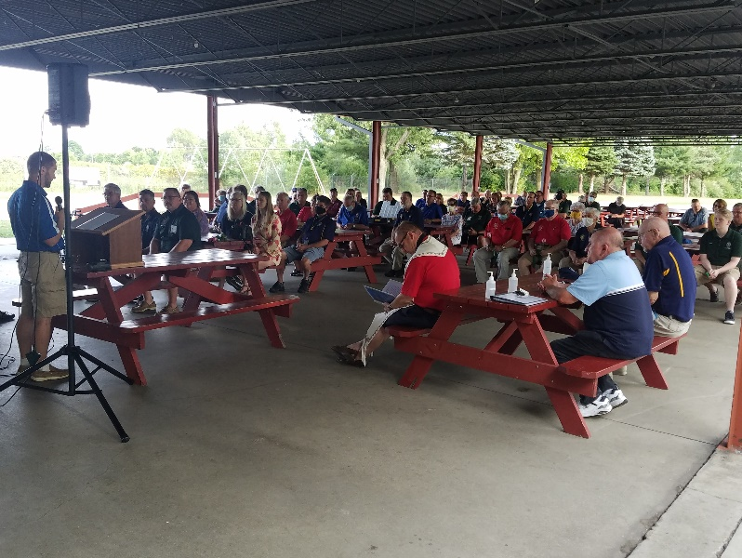

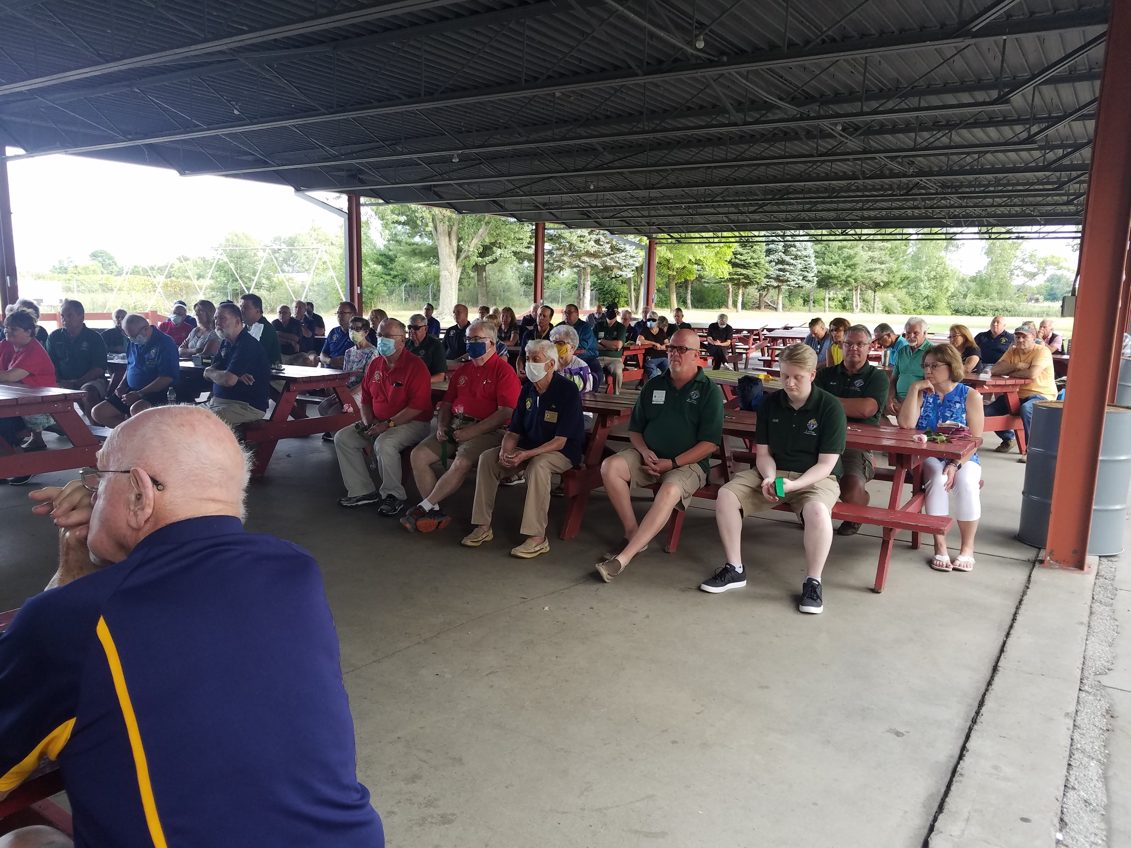

**Group picture of those attending the Officer Installation.**

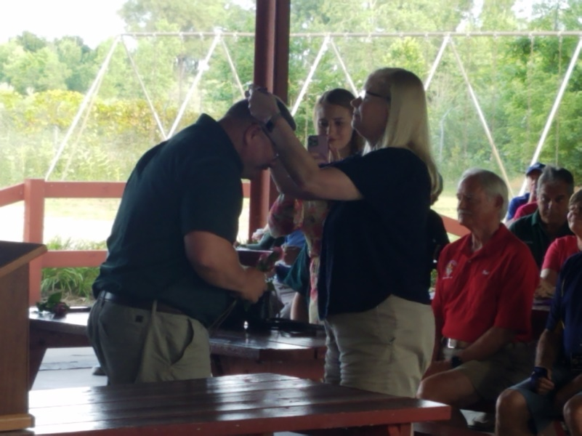 Cheryl Doran presenting Chris, with Guard Medallion & Karen Berg Presenting John, with Grand Knight Medallion

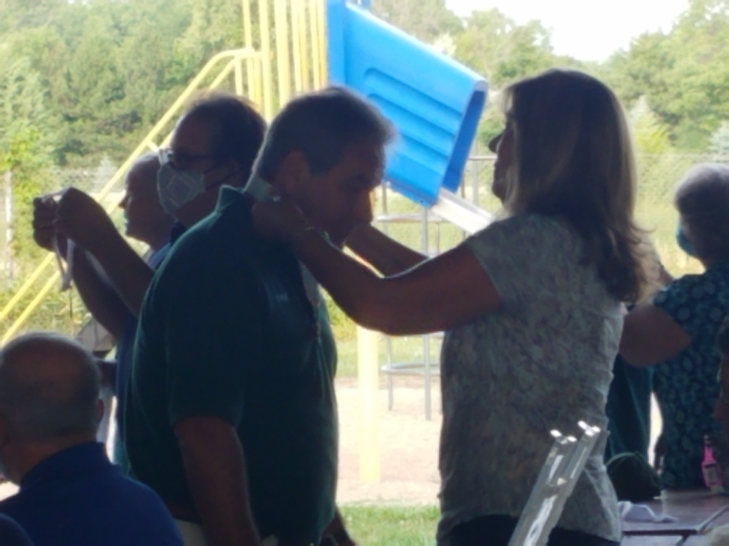

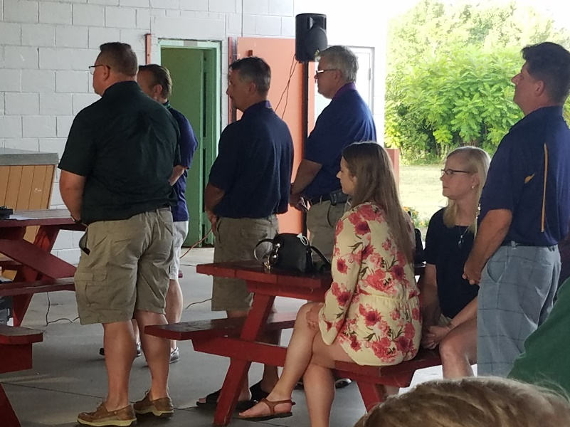

* Grand Knights (rear view) John Berg, Francis Alwart, St. Lawrence and Rick Fisher, St. Therese of Liseau pledging their oath to office.

**AS YOU CAN SEE, OUR COUNCIL IS IN DESPERATE NEED OF A PHOTOGRAPHER! ARE YOU AVAILABLE?**

* **Fall season, when work and education schedules are changing, is a great time to review the insurance coverage for you and your family members. Please contact Dale Jacks, his contact details below, to schedule a date and time to review and/or update your needs and coverages.**



* **PRAYER for VOCATIONS**:

As Knights we are encouraged, along with our family members, to pray for vocations especially as the numbers of people entering the religious and married life continues to decline. We are asking all of us to pray the following prayer daily;

Heavenly Father, call many holy young people to consecrated life for the sake of your kingdom.

Call an abundance of virtuous men to serve in ordained ministry, as laborers for your harvest.

Call numerous others to faithful, chaste and fruitful love in the sacrament of marriage, as signs and

witness of Christ’s love for his Church.

Through baptism you have called all your children, in whatever state of life, to love and serve you.

Fill us with your Holy Spirit and grant us the grace to follow you in perfect obedience and charity.

With Mary and Joseph as our models and intercessors, we ask this through Christ our Lord.

Amen

* **ADORATION CHAPEL**;

The Council has members attending the Adoration of the Blessed Sacrament every Wednesday afternoon from

3:00pm to 4:00pm. The Chapel, located behind the Altar, is open daily from 9:00am till 4:00pm as well.

Won’t you please come and join us in private Adoration?

* **CHRISTMAS CELEBRATION PARTY**;

Our annual Christmas Celebration is scheduled for WEDNESDAY DECEMBER 10th. This event still requires an event planner to organize! Please see Joe Vogel for information on what has to be done and cost associated with the event. You should be able to find another Brother Knight and/or spouse to assist is the organization. Let’s hope & pray that we are able to celebrate and that some of the Covid restrictions are reduced by then.

* **TID BITS**:

Dear God;

Help me be a good sport in this game of life. I do not ask for an easy place in the lineup. Put me anywhere you need me. I only ask that I can give you 100% of everything I have. If all the hard drives seem to come my way, I thank you for the compliment. Help me remember that you never send a player more trouble than he can handle.

Help me to study the Book so I’ll know the rules.

Finally God, if the natural turn of events goes against me and I’m benched for sickness or old age, help me to accept that as part of the game too. Keep me from whimpering that I was framed or that I got a raw deal. And when I finish the final inning, I ask for no laurels. All I want is to believe in my heart that I played as well as I could and that I didn’t let you down!

* God Bless You, Your Family and Your Friends:

Ralph E. Engler

Past Grand Knight & Knight Letter Editor

(586) 201 0220 **greenrpeng@att.net**