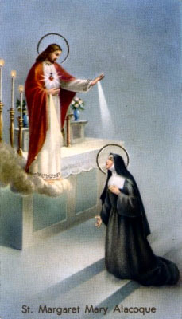
Jesus Wants to be Invited into Your Home and Family, Sign Up to reserve your package today.
You and your family are invited to Enthrone the Sacred Heart of Jesus in your home after the 11:30 am Holy Mass is celebrated on Sunday, June 27, 2021. When Jesus appeared to St. Margaret Mary Alacoque, He told her that He would bless the homes where an image of His Sacred Heart “shall be exposed and honored”.
After the 11:30 am Holy Mass, Fr. Joe will lead you and your family in a short ceremony (20 minutes) including where Father will bless the 8”X10” Sacred Heart of Jesus and Immaculate Heart of Mary image shown below with salt for your home.
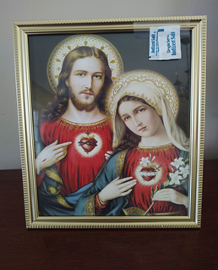
The Men of the Sacred Hearts (firstJesus.org) will provide the image, salt, ceremony book and certificate of Enthronement in a packet that day. There is no cost, but a free will donation envelope is enclosed in the package and of course any donation is appreciated to help with the costs.
If you wish, your family can be photographed with Father and we will email the photo to you for you to mark the occasion and retain as a keepsake.

We request that you please register for the event, so we have enough materials.
Leave registration form in Home Enthronement secure box in the gathering area and PLEASE PRINT CLEARLY
Name: _______________________________________________________________
Street Address: ____________________________________________________________
City, and Zip Code: ________________________________________________________
Cell phone for texting if email bounces ___________________________________________
Email address for sending you the keepsake photo with Father: ___________________________________________________________________________

